3.9 | Te Rapa North Industrial

The Te Rapa North Industrial Zone applies to approximately 230ha of land to the north of Hamilton. It is a strategic industrial growth node identified by the Waikato Regional Policy Statement that is essential to Hamilton and the Waikato Region’s future supply of industrial land.
A Deferred Industrial Zone overlay applies over all parts of the zone outside of the Te Rapa North Industrial Structure Plan area. This overlay applies the Future Urban Zone provisions, maintaining rural activities in these areas, with an anticipation for industrial development in the future.
The Te Rapa North Industrial Structure Plan applies to 91ha of the zone. The Structure Plan will further guide the development of the area to coordinate infrastructure upgrades and achieve good urban design outcomes.
Vision
- The development of the Te Rapa North Industrial Structure Plan has been guided by the following vision:
“To deliver a well-functioning industrial and logistics hub at Te Rapa North that achieves environmental protection while providing economic benefits and productivity gains to the Waikato Region. Central to this will be enabling industrial uses that compliment and protect the ongoing operation of the Te Rapa Dairy Manufacturing Site.”
3.9.1 | Objectives and Policies

- The objectives and policies of Chapter 12 -Te Rapa North Industrial Zone provide guidance for the use and development of this area. The Chapter 12 objectives and policies were developed with specific consideration of the Te Rapa North Industrial Structure Plan area and its surrounds.
- Refer to Chapter 12 and other relevant district plan chapters for the objectives and policies to guide development in accordance with the Structure Plan.
3.9.2 | Components of the Structure Plan

This section provides an explanation of the main land use elements to achieve the vision described in 3.9 a. These elements are incorporated in land use zones and overlays as shown on the Planning Maps and Appendix 2 - Figure 2-22.
3.9.2.1 | Overall

- A 91 ha area centering around the Te Rapa Dairy Manufacturing Site on either side of Te Rapa Road to the north of the Te Rapa suburb of Hamilton City.
- It is bounded by the Waikato River, the Waikato Expressway (SH1), the NIMT and private property boundaries.
- It will provide for approximately 53 ha of (net developable) employment land, that is to be developed as a high-quality industrial precinct and future rail siding for the NIMT.
- The land surrounding the Structure Plan area that is zoned Te Rapa North Industrial, will remain subject to the Deferred Industrial Zone overlay, with the expectation that future plan change processes will live-zone these areas, and update the Structure Plan accordingly.
3.9.2.2 | Industrial Precinct

The Te Rapa North Industrial Structure Plan will guide the development of a high-quality industrial and logistics precinct surrounding the Te Rapa Dairy Manufacturing site.
- The industrial uses sought are to be complementary and not sensitive to the Te Rapa Dairy Manufacturing site.
- Activities associated with industry that are not sought to be enabled within the zone include: Car or boat sale yards/display suites and wet industry.
- Only offices and retail spaces that are ancillary to industrial activities are sought within the zone.
- A limited floor area for office and retail activities is permitted in the zone to enable the spaces that are essential to the function of industrial and logistics activities. Floor area limitations apply to avoid the risk of reverse sensitivity and detracting from existing commercial centres.
- Food and beverage outlets are limited to the Focal Area and within a gfa cap, to meet workers’ daily needs in the Southern part of the Structure Plan area.
- The Structure Plan area is an industrial precinct and as such, the road reserve and boundary treatments have the greatest opportunity for visual amenity outcomes. However, provisions apply which support positive development design outcomes including setbacks and landscaping.
3.9.2.3 | Focal Area

- An approximately 2ha Focal Area is identified in the Structure Plan (Figure 2-22), which is dedicated to meeting the daily needs of people working within the industrial precinct.
- Food and beverage outlets and gymnasiums that are not sensitive to the industrial nature of the area are sought to be enabled.
- Connection with the Riparian and Stormwater Reserve Area to provide access to and/or an outlook over green space.
- It is located within the southern part of the Structure Plan area to provide for the needs of employees in Southern Part of the Structure Plan area and the parts of the TRNIZ that are subject to Deferred Industrial Zone overlay, once developed in future. The Te Awa Lakes Commercial precinct to the north of the Structure Plan Area will meet the needs of workers in this location.
3.9.2.4 | Te Rapa Dairy Manufacturing Site

- The Te Rapa Dairy Manufacturing Site is a regionally significant industrial activity, that employs a significant number of people and is integral to the operation of the dairy industry in the Waikato.
- The existing Te Rapa Dairy Manufacturing Site operations are to remain unchanged and unaffected by the future development guided by the Structure Plan.
- Any development and changes to access and circulation shall not impact the long-term function of the Te Rapa Dairy Manufacturing Site.
3.9.2.5 | Movement Network

The Te Rapa Industrial Structure Plan has been master planned to deliver a functional and efficient multi-modal movement network. The network and road designs support the larger vehicles associated with industrial activities by providing for their safe, efficient and convenient access to Te Rapa Road and the Waikato Expressway, whilst development triggers and setbacks protect the functionality and future upgrades of these corridors. The proposed network supports walking and cycling, with dedicated cycle lanes provided for in Arterial and Collector Road designs (see Figure 3.9.2.5a-c) and footpaths provided across all road designs. Development controls protect the ability of corridors to be upgraded as dedicated rapid transit routes to promote an interconnected network that enables the Structure Plan area to be readily serviced by public transport.
The Structure Plan (Appendix 2 Figure 2-22) indicates the location of the Local, Collector, Major Arterial, State Highway transport corridors and the NIMT. These transport corridors are either existing, designated or yet to be upgraded/constructed.
Timing of Upgrades
- The timing of subdivision and development is coordinated with transport network upgrades, as set out in Rule 3.9.3.2.
Inter-Regional Connectivity
- The transportation network is based on a hierarchy where State Highways and Rail Corridors are at the top and prioritise high volume inter-regional traffic and freight movements. This includes SH1 and the NIMT. These two regionally significant corridors are not within the Structure Plan area, however the future development guided by the Structure Plan will influence the traffic volumes they experience.
- The connection to SH1 via the extension of Koura Drive is indicated by the Structure Plan to protect the future Northern River Crossing (future Major Arterial) between Te Rapa Road and Koura Drive. The intent is for the East-West Road to eventually form part of the Northern River Crossing. The connection to Koura Drive is not required for the Structure Plan area to function in a way that supports the safe and efficient movement of people and goods.
Rail Siding
- The Structure Plan indicates a future rail siding for the NIMT Rail sidings are a form of rail infrastructure that act as a holding location for locomotives to support the efficient distribution of goods and product. The location of the rail siding in Figure 2-22 is indicative, with the preferred location within the Structure Plan area being along the eastern edge of the NIMT.
Arterial
- The Arterial transport corridor networks are designed to cater for high-volume traffic and provide the key connections with the wider City and regional network:
  - Te Rapa Road passes through the Te Rapa North Industrial Structure Plan area. It is anticipated to be upgraded in the long term to include a rapid transit route from the city centre to Te Awa Lakes development. Upgraded infrastructure on Te Rapa Road to support the Te Rapa North Industrial zone includes:
    - Access 2: A new four-way all movement signalised intersection south of Hutchinson Road, providing access to Fonterra North and to the west of Te Rapa Road within the Te Rapa North Industrial Structure Plan area.
    - Four-laning of Te Rapa Road between the Hutchinson Road roundabout and Access 2 intersection
    - New Bus Stops on Te Rapa Road south of the Access 2 intersection
    - A shared walking and cycling path on the eastern side of Te Rapa Road between Hutchinson Road and the Access 2 intersection.
Note
- The Te Rapa Road and McKee Street intersection will be upgraded to a signalised intersection as part of the Te Awa Lakes development in accordance with 3.8 Te Awa Lakes.
- A potential new intersection (by Hamilton City Council) is anticipated to connect Te Rapa Road with the Koura Drive Extension section of the proposed Northern River Crossing arterial, near the existing Pukete Road intersection.
  - The East-West Road in the Te Rapa North Industrial Structure Plan area is designed to be upgraded in future by Hamilton City Council to a Major Arterial, when the Koura Drive Extension section of the Northern River Crossing is constructed. To service development associated with the Te Rapa North Industrial Structure Plan area, the initial East-West Road shall be constructed in accordance with the future-proofed cross-section depicted in Figure 3.9.2.5a. Rule 12.4.1 applies setbacks to this interim design to futureproof the corridor for an Arterial Road, like that depicted in Figure 3.9.2.5b.
  - It is anticipated that Hamilton City Council will use the notice of requirement process to designate the corridors once the precise alignment and design of the new and upgraded Arterial Roads have been determined, including Te Rapa Road and the Northern River Crossing.
Collector
- A central spine Collector Road runs north-south through the Te Rapa North Industrial Structure plan area to the west of Te Rapa Road. It will be designed to accommodate stormwater swales, and watercourse crossings where required. An illustration of the possible cross-section for this road is provided in Figure 3.9.2.5c.
- The Structure Plan anticipates that Old Ruffell Road will be upgraded to a Collector cross-section standard between the central spine Collector Road and Ruffell Road. It will be designed to include provision for a walking and cycling connection between the Plan Change area (along Old Ruffell Road) and bus stops located on Te Rapa Road north of the Te Rapa Road / McKee Street Intersection.
- Some flexibility is afforded in the alignment of the central spine Collector Road, as it will have a key role in accommodating public transport and active and micro-mobility transport routes. As such, the Structure Plan connectivity is an important design element to facilitate the safety of users and provide convenient mode choice options whilst ensuring long-term efficient access for freight to the strategic road network.
Local Roads
- Local Roads will provide access to future land use activities within the Te Rapa North Industrial Structure Plan area. These roads will support the movement of freight vehicles at a low speed (40km/h) and will also accommodate stormwater swales, and watercourse crossings where required. An illustration of a typical cross-section for the Structure Plan area’s local roads is shown in Figure 3.9.2.5d. Local Roads depicted on the Structure Plan are indicative only.

Vehicle Access Restriction
- An access restriction, applying to industrial traffic movements from the Fonterra South and Meadow View East Block is to apply to Meadow View Lane until the Deferred Industrial Overlay is lifted from the properties along this road. This is to prevent noise and traffic impacts along this residential lane.
- The restriction will require heavy vehicles associated with industrial activities in the Fonterra South and Meadow View East Block to access Te Rapa Road via the Te Rapa Dairy Manufacturing Site.
Public Transport
- The Structure Plan area is to facilitate the provision of public transport services so employees, visitors and those travelling to and through the area have a variety of transport options.
- The road network set out in Figure 2-22 either holds space for the upgrade of existing transport corridors (Te Rapa Road) or will deliver roads that are supportive of public transport services (East-West Road and its upgrade as the Northern River Crossing and central spine Collector Road).
- Bus stop facilities will be provided along Te Rapa Road (both sides), on the north side of Te Rapa Road / Mckee Street intersection, near the centre of the Structure Plan area (approximately at the Te Rapa Dairy Manufacturing Site access) and on the south side of the Access 2 intersection.
- Safe crossing places shall be established within the Te Rapa Road corridor in close proximity to the bus stop locations to support both movement between stops and movement between the stops and the Te Rapa North Industrial Structure Plan areas.
Walking and Cycling
- Walking and cycling infrastructure will be provided along new roads to meet the needs of future employees as well as those visiting or passing through the area, with the intention of reducing reliance on motor vehicles through improved access to active travel modes and public transport.
- The East-West Road (future Major Arterial) includes separated footpaths and bi-directional cycle path, as depicted in Figures 3.9.2.5 a-b. The central spine Collector Road and Old Ruffell Road collector upgrade includes a shared walking and cycling path on one berm and a footpath on the opposite berm. Local Roads have dedicated footpaths on both sides and a traffic environment (low operating speed and traffic volumes) that enable cyclists to safely share the road carriageway.
- The setbacks required from Te Rapa Road will maintain space for the future upgrade of this corridor, to deliver walking and cycling facilities.
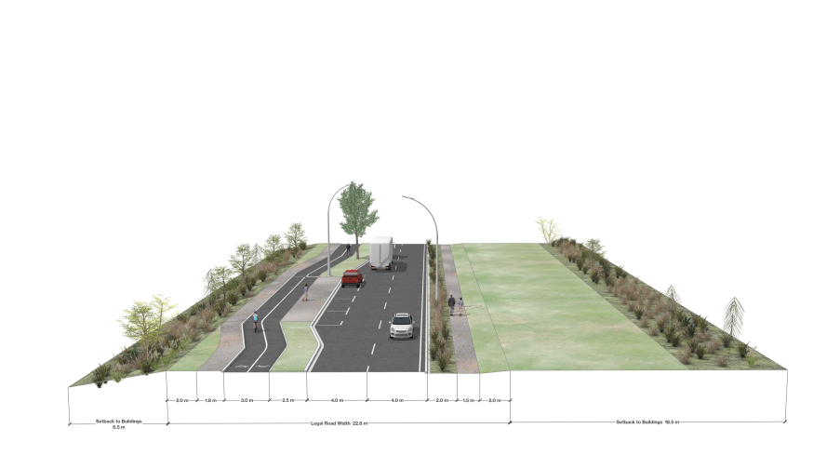
Figure 3.9.2.5.a: Indicative Cross-Section for the East-West Road (Local Road)
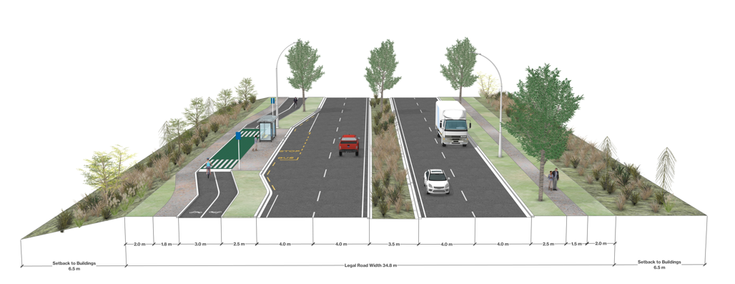
Figure 3.9.2.5.b: Indicative Cross Section of the ultimate Northern River Crossing (Arterial), following upgrade of East-West Road

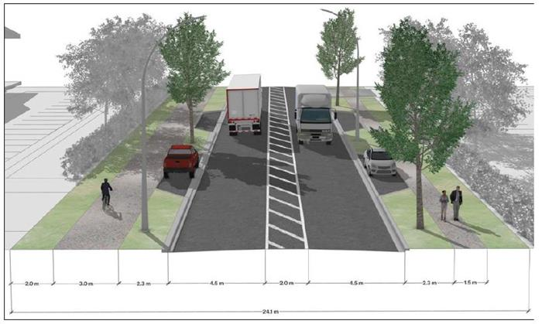
Figure 3.9.2.5.c: Indicative Cross-Section of the Te Rapa Structure Plan Spine Road (Collector)

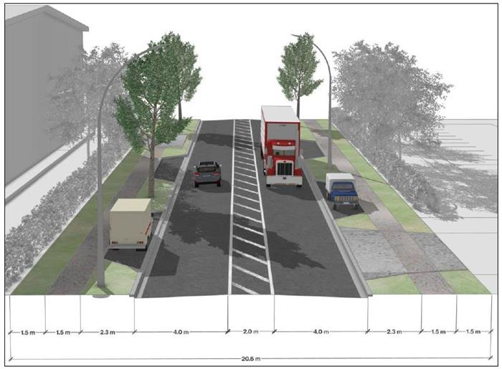
Figure 3.9.2.5.d: Indicative Cross-Section for Local Roads
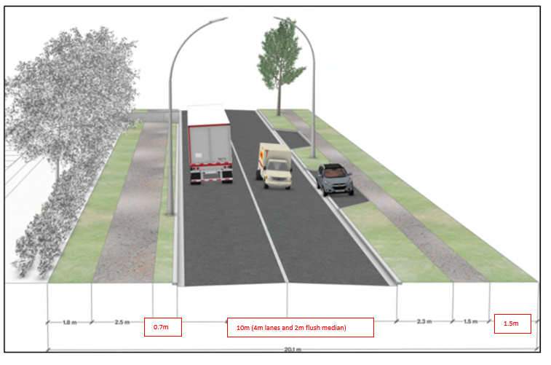
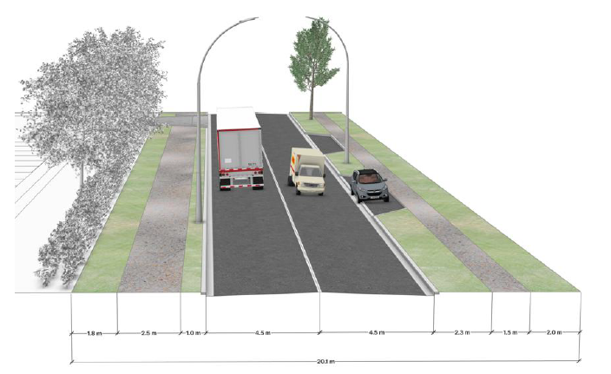
Figure 3.9.2.5.e: Indicative Old Ruffell Road upgrade cross section (Collector)

3.9.2.6 | Wastewater and Water Networks

- Development of the Te Rapa North Industrial Structure Plan area will be progressively enabled based on the capacity of the public network.
- The first application for resource consent for land use, subdivision, or development for the Structure Plan area will be accompanied by an Infrastructure Plan that considers water availability and allocation, details the methods of water supply and conveyance as well as wastewater treatment capacity and management, including any upgrades or new infrastructure that may be required to the public network. The first Infrastructure Plan must consider the future development scenario for the entire Structure Plan area for water and wastewater infrastructure.
- All subsequent applications for resource consent for land use, subdivision, or development, including for later stages, will be accompanied by an Infrastructure Plan that covers the matters as set out in 3.9.2.6.b. Subsequent Infrastructure Plans will refer to the Infrastructure Plan required under Section 3.9.2.6.b and contribute to the completion of its proposed network, in a manner that is coordinated and does not compromise the capacity of existing service users.
- Early interaction with Hamilton City Council by developers is encouraged to coordinate the construction of these assets with the sequencing of urban development and to enable any assets that are private initially, to be vested in future.
3.9.2.7 | Blue-Green Corridor (Ecology and Stormwater Management)

- Te Ture Whaimana o Te Awa o Waikato (Te Ture Whaimana) sets the vision for the Waikato Region, in relation to the Waikato River, seeking a healthy Waikato River sustains abundant life and prosperous communities who, in turn, are all responsible for restoring and protecting the health and wellbeing of the Waikato River, and all it embraces, for generations to come.
- The Waikato Regional Policy Statement, through its endorsement of the Future Proof Strategy, along with Te Ture Whaimana seeks the creation of a regional Blue-Green network, with the Waikato River at its heart.
- A blue-green network is a system of waterways (blue) and open spaces or reserves (green) that gives stormwater space to flow while contributing to the ecology, amenity and sometimes, recreation values of an area. Section B5 of the 2024 Future Proof Strategy directs:
The blue-green network includes regional and local scale landscape features, open space, rivers, gullies and their margins and areas of ecological and conservation value…The networks extend beyond the [Waikato] river itself to include all water bodies within the catchment.
- The Te Rapa North Industrial Structure Plan blue-green network comprises:
  - The Waikato River, its tributaries, all vegetation within the Waikato River riparian setback as well as the Open Space zone and the Significant Natural Areas along this corridor.
  - Te Rapa Stream, its tributaries and associated riparian margins; and
  - Riparian and Stormwater Reserve areas along the Te Rapa Stream corridor.
These features are identified in the Structure Plan (Appendix 2, Figure 2-22)
- The blue-green network’s ecological and amenity values will be maintained and/or enhanced through setback and landscaping provisions. All landscaping required within the identified riparian setbacks are to be indigenous species.
- No development is to occur within the setbacks from identified watercourses, other than within the setback from Te Rapa Stream for activities supporting informal recreation activities, as set out under Rule 12.4.6. Informal recreation areas for local employees to rest are desirable along the riparian setback from the Te Rapa Stream. The Open Space Zone and Significant Natural Area overlays that apply along the Waikato River corridor include consenting pathways for informal recreation facilities in recognition of the benefits these facilities will provide in these locations.
- The Focal Area is intentionally located adjacent to the riparian and stormwater reserve identified in the Structure Plan (Figure 2-22), to increase the amenity provided by this location.
- The protection and enhancement of the ecological values of the Waikato River Corridor recognizes its value as habitat for a range of indigenous flora and fauna, notably the critically endangered pekapeka (New Zealand long-tailed bat). This corridor is known as a roosting, foraging and commuting habitat for pekapeka in other parts of Hamilton. This potential is sought to be protected and enhanced in this part of the Structure Plan area, opposed to areas of industrial development.
- Water sensitive design has been applied across the Structure Plan area to manage stormwater, that further expand upon the ecological and hydrological values to increase biodiversity and protect water quality.
3.9.2.8 | Cultural

- The Te Rapa North area is significant to mana whenua, with a history of occupation by a number of iwi as well as confiscation by the Crown in the years preceding and following the Land Wars, resulting in loss of access to significant sites, traditional food sources and the ability to practice rangatiratanga (chieftainship) and kaitiakitanga (guardianship) over the whenua.
- The Waikato River defines the eastern edge of the Structure Plan Area which is considered by Waikato-Tainui “as a tuupuna (ancestor) which has mana (spiritual authority and power) and in turn represents the mana and mauri (life force) of Waikato-Tainui".
- Development sought within the Structure Plan area shall be informed by engagement with tangata whenua, and where appropriate and supported by rangatira, should incorporate cultural narratives and symbolism.
- The ecological and freshwater values associated with the Waikato River as well as the Te Rapa Stream and its tributaries should be protected through the planting riparian areas with indigenous vegetation to enhance biodiversity and filter water. The mauri, mana and quality of these waterways should be enhanced to give effect to Te Ture Whaimana o te Awa o Waikato.
- The Paa site identified as A32 (S14/17) which is associated with nearby Mangaharakeke Pa site A33 (S14/18), are to be undisturbed by any development occurring within the Structure Plan area and their values protected.
- The interface between the TRNIZ area and the Waikato River will be screened and softened through the planting of indigenous vegetation.
3.9.2.9 | Landscape Values – Interface with Deferred Industrial Zone overlay

- Landscaping required along the interface between the Structure Plan area and the parts of the TRNIZ that remain subject to the Deferred Industrial Zone overlay is to be dense, 5m in width and at least 10m in height within 5 years of planting. The landscaping can be treated as temporary (until such time as the adjacent properties are also rezoned industrial) and use any mixture of non-pest species.

3.9.3 | Rules

3.9.3.1 | Te Rapa North Industrial Structure Plan Area

- All land use and development within the Te Rapa North Industrial Structure Plan area shall be in accordance with:
  - The Te Rapa North Industrial Structure Plan as set out by this chapter;
  - Te Rapa North Industrial Structure Plan in Volume 2, Appendix 2, Figure 2-22, and
  - Indicative Transport Upgrade Location and Extent Volume 2, Appendix 2, Figure 2-23, and
  - Indicative three waters network in Volume 2, Appendix 2, Figures 2-24A, 2-24B, 2-24C, and
  - Chapter 12 - Te Rapa North Industrial Zone and any other zone or district plan provisions that apply.
3.9.3.2 | Transport Upgrade Framework

All land use and subdivision consent applications for development in the Te Rapa North Industrial Zone shall include provision for, and staging of, the relevant transportation infrastructure improvements as follows.
Table 3.9.3.2.a
Minimum Infrastructure Requirement | Implementation Trigger
- Design and construction of the Old Ruffell Road/ Ruffell Road intersection upgrade to a roundabout. | To be completed prior to:  - Any section 224c certificate for subdivision under the Resource Management Act 1991 (‘RMA‘) being issued that takes the cumulative net developable area up to and including 20 ha to the west of Te Rapa Road within the Structure Plan area: or,  - Any industrial / commercial activity to the west of Te Rapa Road within the Structure Plan area generating a cumulative average weekday pm peak traffic volume up to 325 vehicles per hour (two-way), accessing via Old Ruffell Road (Access 1).
Design and construction of the McKee Street/Te Rapa Road to a signalised intersection including a signalised pedestrian crossing of Te Rapa Road.
    - The Collector Road (Structure Plan Spine Road) is designed and constructed in general accordance with the Structure Plan and typical cross-section shown in Figure 3.9.2.5.c, including providing:
- A continuous connection to Old Ruffell Road (Access 1) including a Tee- intersection between the Spine Road and the remaining Old Ruffell Road stub, and
- Future proofing for a four-leg intersection between the Spine Road and the future Northern River Crossing arterial.
- Upgrade of Old Ruffell Road to Collector cross-section standard between the Collector Road (Structure Plan Spine Road) and Ruffell Road as shown in Figure 3.9.2.5.e. including provision for a walking and cycling connection between Te Rapa Road and Old Ruffell Road stub opposite the Te Rapa Road / McKee Street intersection.
Upgrade of Old Ruffell Road to Collector standard in accordance with the indicative cross-section shown in Figure 3.9.2.5.e, between the Structure Plan Spine Road (Access 1) and Ruffell Road. The upgrade shall include provision for a walking and cycling connection between the Structure Plan Spine Road and the existing bus stops north of McKee Street on both sides of Te Rapa Road.
- Completion of items i – iii, above. | To be completed prior to:  - Any section 224c certificate for subdivision under the Resource Management Act 1991(‘RMA‘) being issued that takes the cumulative net developable area in Fonterra North and to the west of Te Rapa Road within the Structure Plan area above 20 ha; or  - Any industrial / commercial activity in Fonterra North and/or to the west of Te Rapa Road within the Structure Plan area that generates a cumulative average weekday pm peak traffic volume exceeding 325 vehicles per hour (two-way), accessing via Old Ruffell Road (Access 1).
- Design and construction of Access 2 on Te Rapa Road as a new four-leg all movement signalised intersection.
- The Collector Road (Structure Plan Spine Road) from Access 2 is designed and constructed in general accordance with the Structure Plan and typical cross-section shown in Figure 3.9.2.5.c.
- New northbound and southbound bus stops located on the Te Rapa Road south leg of the Access 2 intersection
- Shared walking and cycling paths on both sides of Te Rapa Road connecting Access 2 intersection to the new bus stops
- Provision of four continuous traffic lanes on Te Rapa Road between the Hutchinson Road roundabout and the Access 2 intersection
- A shared walking and cycling path on the eastern side of Te Rapa Road connecting to the existing shared path from Hutchinson Rd
- Permanent closure of two existing vehicle crossings to #1426 Te Rapa Road and provision of one new commercial vehicle crossing to the same property from the new eastern leg of the Access 2 intersection.
The Collector (Spine) Road is connected through the Structure Plan West Block between the Access 2 Intersection and the Old Ruffell Road intersection (Access 1).
- The Collector Road (Structure Plan Spine Road) is connected through the Interchange Block between the Access 2 Intersection and Old Ruffell Road intersection.
- Completion of items i – xiii, above. | To be completed prior to:  - Any section 224c certificate for subdivision under the Resource Management Act 1991(‘RMA‘) being issued that takes the cumulative net developable area in Fonterra North and to the west of Te Rapa Road within the Structure Plan area above 35 ha: or,  - Any industrial / commercial activity in Fonterra North and to the west of Te Rapa Road within the Structure Plan area that generates a cumulative average weekday pm peak traffic volume exceeding 570 vehicles per hour (two-way)
- The Collector Road (Structure Plan Spine Road) is connected through the Interchange Block between the Access 2 Intersection and Old Ruffell Road intersection.

- Completion of items i – xiiivi, above.  - Design and construction of a capacity upgrade to Te Rapa Road / Ruffell Road intersection (additional northbound and southbound through movement lanes). | To be completed prior to:  - Any section 224c certificate for subdivision under the Resource Management Act 1991(‘RMA‘) being issued that takes the cumulative net developable area in Te Rapa North Structure Plan area up to 42 ha: or,  - Any industrial / commercial activity in the Te Rapa North Structure Plan area that generates a cumulative average weekday pm peak traffic volume up to 685 vehicles per hour (two-way)
- Completion of items i – xvi, above. | To be completed prior to:  - Any section 224c certificate for subdivision under the Resource Management Act 1991(‘RMA‘) being issued that takes the cumulative net developable area in Te Rapa North Structure Plan above 42 ha; or  - Any industrial / commercial activity in the Te Rapa North Structure Plan area that generates a cumulative average weekday pm peak traffic volume exceeding 685 vehicles per hour (two-way), and  - The average weekday am peak hour traffic volume on Te Kowhai Road eastbound approach entering the Te Rapa Road / Te Kowhai Road roundabout exceeds 790 vehicles per hour.
- A Level Crossing Safety Impact Assessment (LCSIA) for the Ruffell Road level crossing that demonstrates the further upgrades (if any) required to safely reopen the temporary closure of the level crossing.
- Completion of the identified safety upgrades to the satisfaction of KiwiRail and Hamilton City Council, and the reopening of level crossing to traffic in both directions
- A road connection being provided through the existing Dairy Manufacturing Site from the Fonterra South and Meadow View East sub-blocks to access through the interchange on Te Rapa Road. | To be completed prior to:  - Any section 224c certificate for subdivision under the Resource Management Act 1991 (‘RMA‘) being issued for development within the Fonterra South and Meadow View East sub-blocks.
- No vehicle access is provided from any Industrial activity in the Fonterra South and Meadow View East sub-blocks to Meadow View Lane south of Lot 1 DPS 18043 the intersection of Meadow View Lane and Pukete Road.
- Design and construction of a new 3m wide off-road shared unsealed path for the purposes of use by cyclists and pedestrians along the east side of the section of Meadow View Lane fronting Industrial activity in the Fonterra South and Meadow View Blocks.
Note: Refer to Figure 2-23 containing the indicative location and extent of the minimum infrastructure requirements set out in Table 3.9.3.2.a.
- All applications that fail to meet Rule 3.9.3.2.j.-xiv. shall be supported by a Simple ITA that meets the requirements of section 15-2 of the District Plan.
- The first resource consent for land use, subdivision, or development in the Te Rapa North Industrial Structure Plan subject to Rule 3.9.3.2. iv, xvii – xix iv – xiv and xv - xxii. shall be supported by a Broad ITA that meets the requirements of section 15-2 of the District Plan, that:
  - Identifies and evaluates the effects of all cumulative development in the Structure Plan area on the infrastructure identified for improvements in the Table 3.9.3.2.a.
  - Assesses the capacity and safety of the adjoining road network, including the:
- SH1C Horotiu Interchange roundabouts;
- Te Rapa Road / McKee Street signalised intersection;
- Te Rapa Road / Hutchinson Road roundabout;
- Te Rapa Road / Ruffell Road signalised intersection;
- Te Rapa Road / Kapuni Street intersection;
- Te Rapa Road / Te Kowhai Road / Church Road intersection;
- Old Ruffell Road / Ruffell Road intersection; and
- Te Rapa Road corridor (between Access 2 and Church Road)
  - Evaluates the feasibility of completing any LCSIA identified safety upgrades.
  - Includes evidence of consultation with Waka Kotahi NZ Transport Agency, KiwiRail (where relevant), Fonterra Limited, Waikato Regional Council, Te Awa Lakes, IAWAI – Flowing Waters, relevant network utility providers and how any feedback from these organisations has been addressed.
  - Provides recommendations for any further infrastructure upgrades to be undertaken to adequately mitigate the assessed cumulative effects of the proposed development in the Structure Plan area.
- The recommended infrastructure upgrades in the Simple ITA andBroad ITA, or such alternatives accepted by Hamilton City Council, Kiwi Rail and NZTA (the latter two where approval is legally required), are completed prior to the section 224c certificate for subdivision under the Resource Management Act 1991(‘RMA‘) is issued.

3.9.3.3 Strategic Three Waters Infrastructure
An Indicative staging framework has been developed for the Te Rapa North Industrial Zone to ensure that urbanisation does not occur without considering water availability and allocation, wastewater treatment capacity and ahead of the delivery of key strategic infrastructure. The framework provides for the flexible sequencing development with water availability, wastewater capacity, and the availability of water, wastewater and stormwater networks.
Please note that once the enabling work has been completed, the remaining stages can occur in any order provided the preceding stages have been completed and subject to the necessary capacity considerations and infrastructure requirements for each of the remaining stages being confirmed and implemented in accordance with the Infrastructure Plan.

Refer to Figures Appendix 2, Figures 2-24A, 2-24B, and 2-24C for the indicative locations of strategic infrastructure and the information requirements for Water Impact Assessments and Three Waters Infrastructure Capacity Assessments in Appendix 1 (sections 1.2.2.5 and 1.2.2.5a).
Table 3.9.3.3.a
Stage  /Sub-Block¹ | Preceding stage(s)  /Sub-Block(s)¹ required  (*Wastewater, **Water) | Strategic Infrastructure Requirements
Stage  /Sub-Block¹ |  | Wastewater | Water | Stormwater
Enabling Work (to precede stages below). | - | Preparation of an Infrastructure Plan, in accordance with the requirements of Rule 3.9.3.4.
Enabling Work (to precede stages below). | - | Pukete Road Gravity Network (1B, 1C)  Pump Station and Rising Main or an interim solution to be agreed with Hamilton City Council  Pumping Station PS5 and Rising Main (1D, 1E)  Confirmed availability of wastewater treatment plant capacity | Confirmed water allocation and availability | Te Rapa Stream erosion resilience works in accordance with the Infrastructure Plan or to a level mutually agreed upon by Hamilton City Council and Waikato Regional Council
Ruffell East | Pukete Block*  Interchange Block* | Gravity Main 4  Confirmed availability of wastewater treatment plant capacity | Pipe upgrade on Old Ruffell Rd (W3)  Confirmed water allocation and availability | Wetland B  Rip Rap stream bed works within Area 1 as identified in Appendix E of the Te Rapa ICMP  Te Rapa Stream erosion resilience works in accordance with the Infrastructure Plan  Culvert 3²
Ruffell West | Onion South*  Onion North*  Interchange Block*  Ruffel East**  Onion South** | Gravity Main 3  Confirmed availability of wastewater treatment plant capacity | Water Main W6 (within Ruffel West)  Confirmed water allocation and availability | Wetland C  Te Rapa Stream erosion resilience works in accordance with the Infrastructure Plan  Culvert 3²
Onion South | Onion North*  Interchange Block*  Ruffell East and Ruffell West** | Gravity Main 3  Confirmed availability of wastewater treatment plant capacity | Southern Te Rapa upgrade (W4)  Confirmed water allocation and availability  Water Main W5 (to East) | Wetlands C & D  Rip Rap stream bed works within Area 1 as identified in Appendix E of the Te Rapa ICMP  Te Rapa Stream erosion resilience works in accordance with the Infrastructure Plan  Culvert 2²
Onion North | Interchange Block*  Ruffell East and Ruffell West**  Onion South**  or  Pukete Block**  Interchange Block** | Gravity Main 3  Confirmed availability of wastewater treatment plant capacity | Confirmed water allocation and availability | Wetland E  Rip Rap stream bed works within Area 1 as identified in Appendix E of the Te Rapa ICMP  Te Rapa Stream erosion resilience works in accordance with the Infrastructure Plan  Culvert 1² & 2²
Pukete Block | Interchange Block* | Gravity Main 2  Confirmed availability of wastewater treatment plant capacity | Connection to Southern Te Rapa upgrade (W4)  Confirmed water allocation and availability | Wetland B  Rip Rap stream bed works within Area 1 as identified in Appendix E of the Te Rapa ICMP  Te Rapa Stream erosion resilience works in accordance with the Infrastructure Plan  Culvert 2²
Fonterra South | Meadowview East* | Confirmed availability of wastewater treatment plant capacity | Upgrade of Meadowview Water network (W1)  Confirmed water allocation and availability | New South River Outlet  Te Rapa Stream erosion resilience works in accordance with the Infrastructure Plan
Meadow View East | - | Pumping Station PS4  Meadowview Rising Main (14, 15)  Confirmed availability of wastewater treatment plant capacity | Upgrade of Meadowview Water network (W1)  Confirmed water allocation and availability | New South River Outlet  Te Rapa Stream erosion resilience works in accordance with the Infrastructure Plan
Interchange Block | Pukete Block**  Or  Onion North Block**  Onion South Block**  Ruffell East and Ruffell West** | Pumping Station PS3  Rising Main 1A  Confirmed availability of wastewater treatment plant capacity | Confirmed water allocation and availability | Wetland B  Rip Rap stream bed works within Area 1 as identified in Appendix E of the Te Rapa ICMP  Te Rapa Stream erosion resilience works in accordance with the Infrastructure Plan  Culvert 2²
Te Rapa North | Interchange Block*  Pukete Block**  Interchange Block**  Or  Onion North Block**  Onion South Block**  Ruffell East and Ruffell West** | Pumping Station PS2  Rising Main 6  Confirmed availability of wastewater treatment plant capacity | Confirmed water allocation and availability | Wetland A  Rip Rap stream bed works within Area 1 as identified in Appendix E of the Te Rapa ICMP  Te Rapa Stream erosion resilience works in accordance with the Infrastructure Plan  Culvert 1 & 2²
Fonterra North | Te Rapa North*  Interchange Block* | Pumping Station PS1  Rising Main (12)  Confirmed availability of wastewater treatment plant capacity | Confirmed water allocation and availability | North River Outlet  Te Rapa Stream erosion resilience works in accordance with the Infrastructure Plan
Note:
- All Stages/Sub-Blocks will be subject to allocation and capacity assessment, in accordance with the requirements of an Infrastructure Plan, required under Rule 3.9.3.4.
- Refer to Appendix 2, Figure 2-22 for Stage/Sub-block locations.
- The need for these culverts must be demonstrated by detailed flood modelling.
3.9.3.4 | Information Requirements

- Infrastructure Plan
  - The first resource consent for land use, subdivision, or development for each stage of the Te Rapa North Industrial Zone (including sub-blocks identified in Rule 3.9.3.3 Table 3.9.3.3.a) must be accompanied by an Infrastructure Plan that provides the information set out in 1.2.2.30. The first Infrastructure Plan must consider the future development scenario for the Structure Plan area for water and wastewater infrastructure.
  - All subsequent applications for resource consent for land use, subdivision, or development within the stage shall demonstrate their consistency with the outcomes of the Infrastructure Plan that was approved as part of the first land use or subdivision resource consent within the relevant stage in accordance with Rule 3.9.3.4.a.i, or any variation thereof approved by way of a subsequent resource consent (including current applications).
  - Where there is an inconsistency with the Infrastructure Plan required under 3.9.3.4.a.i, the application must demonstrate how it meets the requirements set out in 1.2.2.30.

- Ecological Management Plan
  - The first resource consent for land use, subdivision, or development for each stage of the Te Rapa North Industrial Zone must be accompanied by an Ecological Management Plan that provides the information set out in Information Requirements 1.2.2.31.
  - All subsequent applications for resource consent for land use, subdivision, or development within the stage shall demonstrate their consistency with the Ecological Management Plan that was approved as part of the first land use or subdivision resource consent within the relevant stage in accordance with Rule 3.9.3.4.b.i, or any variation thereof approved by way of a subsequent resource consent (including current applications).
  - Where there is an inconsistency with the Ecological Management Plan required under 3.9.3.4.b.i, the application must demonstrate how it meets the requirements set out in 1.2.2.31.
- Landscape Concept Plans
  - The first resource consent for land use, subdivision, or development lodged for land within each stage of the Te Rapa North Industrial Zone must be accompanied by a Landscape Concept Plan covering the spatial extent of the stage within which the site is located and including the Information Requirements set out in 1.2.2.32.
  - All subsequent applications for resource consent for land use, subdivision, or development within the stage shall demonstrate their consistency with the Landscape Concept Plan required under 3.9.3.4.i, approved as part of the first land use or subdivision resource consent within the relevant stage, or any variation thereof approved by way of a subsequent resource consent (including current applications).
  - Where there is an inconsistency with the Landscape Concept Plan required under 3.9.3.4.c.i, the application must demonstrate how it meets the requirements set out in 1.2.2.32.
3.9.3.5 | Activity Status

- Any application for resource consent in the Te Rapa North Industrial zone not in accordance with Rules 3.9.3.1.a, 3.9.3.2 or 3.9.3.3 is a Non Complying activity
- Any application for resource consent that does not provide the information specified in Rules 3.9.3.4 or is sought without this information having been provided by a previous consent, is a Non Complying activity.
3.9.4 | Provisions in Other Chapters

The provisions of the following chapters apply to activities within this chapter where relevant:
- Chapter 2: Strategic Framework
- Chapter 12: Te Rapa North Industrial Zone
- Chapter 14: Future Urban Zone
- Chapter 15: Open Space Zones
- Chapter 19: Historic Heritage
- Chapter 21: Waikato River Corridor and Gully Systems
- Chapter 22: Natural Hazards
- Chapter 23: Subdivision
- Chapter 24: Financial Contributions
- Chapter 25: City-wide
- Volume 2, Appendix 1: District Plan Administration
- Volume 2, Appendix 2: Structure Plans

